**Importance Ranking Calum**

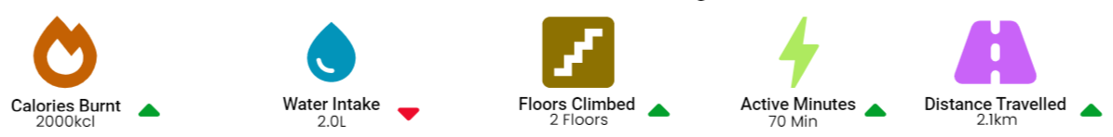

**Description**

These Icons are the data being displayed on the catchup page feeding in from the clients FitBit Live.

**Ranking**: 9 / 10

**Comments**: Would put steps up instead of distance travelled

**Description**

This graph displays the clients steps from the week with regard the goal set for them by their Trainer

**Ranking**: 7 / 10

**Comments**: No need for a graph in my opinion, but still very useful information

**Description**

These are the clients goals set for the trainer by the client, these are used to show the trainer what the client wants

**Ranking**: 7 / 10

**Comments**: Don’t need a constant reminder but good if clients goal changes, could that be shown with an update icon

**Description**

This area is used to input the trainers thoughts at the end of a catchup meeting, to serve as a reminder when they are on the manage page. The notes are visible on the manage page.

**Ranking**: 8 / 10

**Comments**: Good for use on manage page

**Description**

This is the clients intake compared to the goals set by the trainer. The week icons on bottom show whether or not the client reached the target.

**Ranking**: 8 / 10

**Comments**: Very useful information, I like the weekly checks

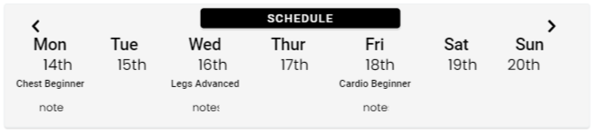

**Description**

This shows the clients workout schedules, set by the trainer. The schedule also contains any feedback the client input at the end of a workout for the trainers viewing

**Ranking**: 9 / 10

**Comments**: Very good, use of clients notes very good feature, would use that a lot before the catchup meeting

**Description**

This shows the clients personal best for any exercise they are improving with, the weight is input by the client

**Ranking**: 7 / 10

**Comments**: Might not be relevant regarding certain clients

**Description**

This graph displays the clients weight progression over their time with the personal trainer

**Ranking**: 7 / 10

**Comments**: Good feature but might not be relevant as client may not be losing weight if they are losing fat and building muscle

[Link to UI for Use](https://app.uizard.io/p/74877f9d)

**Client Side Importance – Calum**

**Description**

This displayed the name and date of the clients next workout

**Ranking**: 10 / 10

**Comments**: Very important for clients as it will help them to follow coaches orders

**Description**

This displays the clients daily steps for the day against the goal set by the Trainer feeding in from their fitbit

**Ranking**: 8 / 10

**Comments**: Very important for clients that are trying to lose weight or lean out



**Description**

This displays the clients sleep ranking from the night before feeding in from their fitbit

**Ranking**: 5 / 10

**Comments**: Not all clients will use this

**Description**

This displays the clients live heart rate feeding in from their fitbit

**Ranking**: 5 / 10

**Comments**: No that important as it will be viewed during workout on the fitbit itself

**Description**

This displays the clients current intake for the day, along with the macros of each meal

**Ranking**: 8 / 10

**Comments**: Very good to have this in the one app instead of having to use the likes of MyFitnessPal as well

**Description**

This displays the clients total calories for the day against the goal set for them by the trainer

**Ranking**: 8 / 10

**Comments**: Same as the calorie input section

**Questionnaire - Calum**

**Is there any additional FitBit data you feel should be shown? Or widgets on the dashboard?**

No, whats there already is perfect. Might not need distance travelled

**Are there any additional ways you feel the clients progression over time should be shown (graphs?)**

Body composition, could not be losing any weight but could be losing fat and building muscle

**Do you feel there is too much information on the catchup page?**

Could move steps up top, instead of distance travelled, to leave more free space

**Do you feel the catchup notes is a useful feature? Considering that you have to go to a different page to prepare your clients schedule.**

Yes it is useful, however could be better to have all on one page